Dorothy I. (Ziegler) Spangler
November 7, 1929 – May 20, 2001

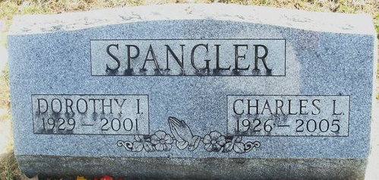
Photo by Alicia Kneuss

Dorothy I. Spangler, 71, died Sunday at Ossian Health & Rehab Center. Born in York, Pa., she was a homemaker.
Surviving is her husband, Charles L.; a son, Norval L. of Fort Wayne; three daughters, Roxann Schible and Carol Rehm, both of Fort Wayne, and Cheryl Orozco of Odessa, Texas; and three grandchildren. She was preceded in death by a son, Charles.
Services at 2 p.m. Wednesday at Haggard & Sefton Funeral Home, Decatur. Calling from 4 to 8 p.m. Tuesday. Burial in Decatur Cemetery.
Memorials to Adams County Home Health or Ossian Health Rehab Center Fund.

Journal Gazette, Allen County, Indiana
Monday, May 21, 2001

**
Indiana, U.S., Death Certificates, 1899-2017
Name Dorothy I Spangler
[Dorothy I Zeigler]
Gender Female
Race White
Marital Status Married
Age 71
Birth Date 7 Nov 1929
Birth Place York, Pennsylvania
Death Date 20 May 2001
Death Place Ossian, Wells, Indiana, USA
Death Registration Date 2001
Father Charles H Zeigler
Mother Mabel I Garner
Spouse Charles L Spangler
Informant Mrs. Roxann Schible; daughter; Fort Wayne, Indiana
Burial May 23, 2001; Decatur Cemetery; Decatur, Indiana

