Charles L. Spangler
April 5, 1926 – February 20, 2005

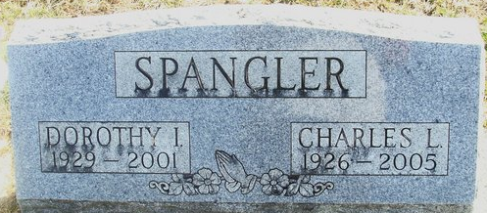
Photo by Alicia Kneuss

Charles L Spangler, 78, of Ossian, Indiana, formally Decatur, Indiana, died Sunday, February 20, 2005, at the Ossian Health Care Ossian, Indiana. Born on April 5, 1926, in Fort Wayne, Indiana, he was the son of Christopher and Beatrice (Lawson) Spangler. He married Dorothy I (Zeigler) Spangler on July 23, 1953, she preceded him in death May 2001.
He retired in 1978 from Schafer Glove Company.
Surviving is a son, Norval L. Spangler of Fort Wayne, Indiana; three daughters, Mrs. Brian (Roxann) Schible of Fort Wayne, Indiana, Mrs. Kevin (Carol) Rehm of LaGrange, Indiana, Cheryl Spangler of Odessa, Texas; three grandsons; a sister; Doris Neal of Prospect, Pennsylvania. He was also preceded in death by a son, Charles; two grandsons, Christopher and Jonathan VanCleve; and a sister, Geneieve Plunkard.
Funeral services is 11 a.m. Wednesday at Haggard & Sefton Funeral Home, Decatur, Indiana, with Rev Richard Shiveley officiating. Visitation is from 4 to 8 p.m. today at the funeral home. Burial in Decatur Cemetery.
Memorials to Samarian Purse.

News-Sentinel, Allen County, Indiana
Tuesday, February 22, 2005

