Mary (Rex) Spahr
September 2, 1887 – August 3, 1947

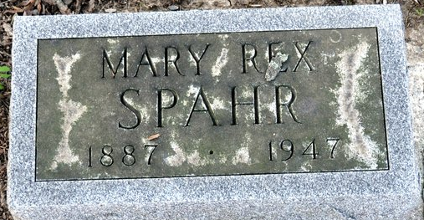
Photo by Deb Curry

Mary R Spahr
in the Indiana, U.S., Death Certificates, 1899-2017
Name Mary R Spahr
[Mary R Rex]
Gender Female
Race White
Marital Status Married
Age 59
Birth Date 2 Sep 1887
Birth Place Ossian, Indiana
Death Date 3 Aug 1947
Death Place Wabash, Wabash, Indiana, USA
Death Registration Date 1947
Father John Rex
Mother Susan Rupright
Spouse Dale Spahr
Informant Dale Spahr; Wabash, Indiana
Burial August 6, 1947; Maplewood Cemetery; Decatur, Indiana

