Ralph J. Spade
March 29, 1906 – March 4, 1945

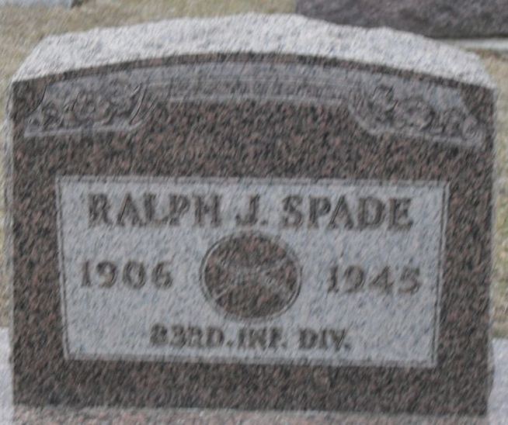
Photo by Stephen & Andrea Brangan

RECEIVES DETAILS OF RALPH SPADE'S DEATH
Soldier Accidentally Slain By Comrade
Pfc. Ralph J. Spade, whose death occurred in Germany on March 4, was accidentally shot by a comrade who was cleaning his rifle in the room in which they were sitting, Chaplain Ernest E. Heuer of Headquarters, 329th Infantry, has informed the soldier's wife, Mrs. Mary K. Spade, 727 North Fifth street.
Chaplain Heuer personally wrote to Mrs. Spade under date of March 14, and explained how her husband met his tragic death with the American troops in Germany.
His letter, in part, follows:
"Ralph was a jeep driver for officers traveling between their headquarters and other units; he had performed this work the past eight months. He was accidentally shot while sitting in the room with another soldier who was cleaning his rifle. The bullet penetrated the upper part of his body. He was unconscious the few minutes that he lived after being wounded. A medical officer was on hand to attend him, but human hands are helpless when the Lord decrees otherwise.
"Ralph was laid to rest in an American military cemetery in Holland. Appropriate funeral services were conducted by a Protestant chaplain.
"There, beneath a neat while cross, resting beside other brave comrades, he awaits the resurrection summons of the Prince of Peace.
" We pray the Lord in mercy comfort you and give you the strength to face the future courageously. God bless you and keep you.""
Pfc. Spade was a son of Mr. and Mrs. Frank Spade of Peterson. Prior to joining the army he was employed at the General Electric plant in this city.

Decatur Daily Democrat, Adams County, Indiana
April 7, 1945

**
Ralph Jackob Spade from tree Miller Family Tree
Birth 29 Mar 1906 Adams, Indiana, USA
Residence 1940 Decatur, Adams, Indiana, USA
Marriage 7 Mar 1941 Paulding, Paulding, Ohio, USA
Death 4 Mar 1945 Germany
Father Frank W Spade (1872-1951)
Mother Eva L. Spade (1882-1958)
Spouse Mary Katherine Holmes (1905-1984)

