Frank W. Spade
February 13, 1872 – September 24, 1951

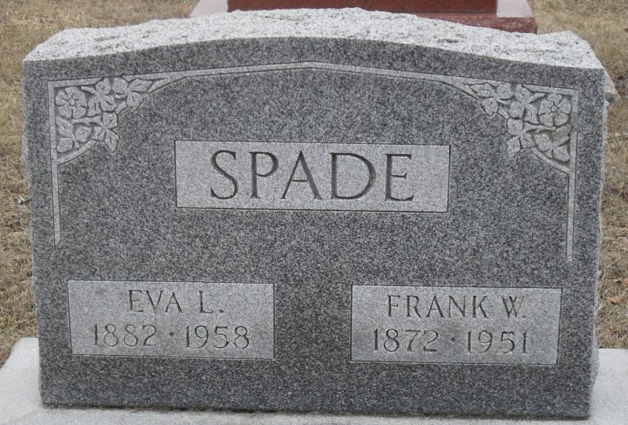
Photo by Stephen & Andrea Brangan

Frank Spade Rites To Be Wednesday
Funeral services for Frank W. Spade, 79, of Peterson, whose sudden death occurred Monday at his home following a heart attack, will be held at 2:30 p.m. Wednesday at the Zwick Funeral Home at Decatur. Rev. Frank H. Kise will conduct services and burial will be in the Decatur Cemetery.
Mr. Spade was husking corn when he was stricken and his body was found by his wife.
He was an employe for some years of the Indiana Pipe Line Company and later was an employe of the Cloverleaf Creameries.
He was born in Kirkland Township, a son of Jacob and Mary Ann Kiser Spade. His marriage was to Eva L. Tucker, Dec. 24, 1898. He was a member of the Beulah Chapel Methodist Church.
Surviving are the wife, five daughters, Mrs. Ida Dilling, of Griffith, Mrs. Iva Kelly, Mrs. Gladys McBride, Mrs. Jeannette Heller and Mrs. Velma Liechty, all of Decatur; a daughter-in-law, Mrs. Katherine Spade, of Fort Wayne; eight grandchildren; six great-grandchildren; a brother, James, of Rome City, and two sisters, Mrs. Jeannie Sweigart, of Boulder, Colo., and Mrs. Cora Good, of Massillon, O. A son, Ralph, was killed in Europe in World War II. Four brothers and three sisters are deceased.

Helen Ebnit’s Green Scrapbook
Unknown source

**
Indiana, U.S., Death Certificates, 1899-2017
Name Frank W Spade
Gender Male
Race White
Marital Status Married
Age 79
Birth Date 13 Feb 1872
Birth Place Indiana
Death Date 24 Sep 1951
Death Place Peterson, Adams, Indiana, USA
Death Registration Date 1951
Father Jacob Spade
Mother Mary Ann Kiser
Informant Mrs. Eva L. Spade; Peterson, Indiana
Burial September 26, 1951; Decatur Cemetery; Decatur, Indiana

