Eva L. (Tucker) Spade
April 10, 1882 – December 11, 1958

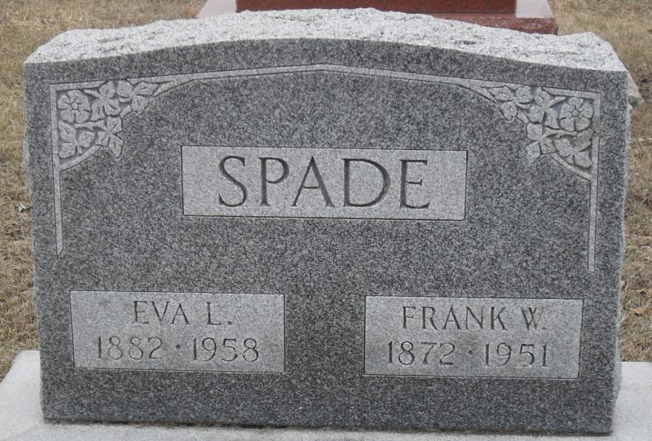
Photo by Stephen & Andrea Brangan

Died at noon today in Peterson, Indiana, where she had been living the past eleven weeks. She had been ill the past eighteen months.

Decatur Daily Democrat, Adams County, Indiana
December 11, 1958
**
Indiana, U.S., Death Certificates, 1899-2017
Name Mrs Eva L. Spade
[Mrs Eva L. Tucker]
Gender Female
Race White
Marital Status Widowed
Age 76
Birth Date 10 Apr 1882
Birth Place Indiana
Death Date 11 Dec 1958
Death Place Decatur, Adams, Indiana, USA
Death Registration Date 1958
Father Herman Tucker
Mother Ella Pierce
Informant Mrs. Arthur Kelly; daughter; Decatur, Indiana
Burial December 14, 1958; Decatur Cemetery; Decatur, Indiana

