Agnes G. (Eady) Sowle
April 13, 1894 – March 6, 1922

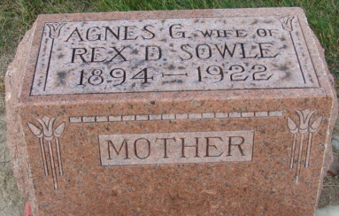
Photo by Alicia Kneuss

DIED YESTERDAY - Mrs. Rex Sowle Passes Away Yesterday Morning at Jackson, Mich., Home
HAD BEEN IN ILL - Health for Six Weeks
Remains Arrive at Home of Parents This Noon

It was with the deepest sorrow that the relatives and friends received the information yesterday of the death of Mrs. Rex Sowle, formerly Miss Agnes Eady of this city, and whose death occurred at 5:30 o'clock Monday morning at the home in Jackson, Mich. Mrs. Sowle had been in very delicate health for the past six weeks, and her mother, Mrs. Enoch Eady, of this city, had been at her bedside for about three weeks. Although relatives here were aware of the fact that Mrs. Sowle's condition was very serious, they had no idea that it would prove fatal, and the news of her untimely demise comes as a severe shock and grief, not only to the relatives but to the large host of friends that the young lady had in this community.
Mrs. Sowle was born in this city April 13, 1894, and was the daughter of Mr. and Mrs. Enoch Eady. She received her education in the city schools, being a member of the graduating class of 1913 of the high school. Following her graduation, she completed a teacher's course at Winona Lake, and the following winter was a teacher in the schools of Blue Creek Township. On May 6, 1916, she was united in marriage to Mr. Rex Sowle and shortly afterward the couple moved to Fort Wayne where they made their home until about two years ago, when they removed to Jackson. Mrs. Sowle was one of the most popular young ladies of the city, highly respected and esteemed by all who were acquainted with her. She had a very winning personality, and was an ardent worker in the local Methodist church during her residence here, and the news of her death causes great sadness to the large circle of friends that she had formed.
Besides the husband, the deceased is survived by the mother and father, four sisters and three brothers.
The remains were brought to this city at noon over the G. R. & I. and were taken to the home of the parents, corner of Sixth and Jefferson Streets. Funeral arrangements had not as yet been made but will be announced later.

Decatur Daily Democrat; Adams County, Indiana
Tuesday, March 7, 1922
**

Indiana Births, 1880-1920
Name: Eady
Father: Enoch; Mother: Nellie Andrews
County: Adams; Gender: Female
Birth Date: 13 Apr 1894
Reference: Adams County, Indiana Index to Birth Records 1882 - 1920 Inclusive Volume I Letters A - Z Inclusive; Book: H-3, Page: 22

