Verdella V. (Everett) Souder
August 13, 1915 – July 22, 1996

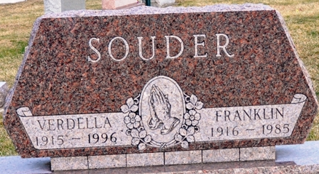
Photo by Deb Curry

Verdella V Souder
in the Indiana, U.S., Death Certificates, 1899-2017
Name Verdella V Souder
[Verdella V Everett]
Gender Female
Race White
Marital Status Widowed
Age 80
Birth Date 13 Aug 1915
Birth Place Wren, Ohio
Death Date 22 Jul 1996
Death Place Decatur, Adams, Indiana, USA
Death Registration Date 1996
Father Lester V Everett
Mother Grace C Cully
Informant Alvin J. Souder; son; Decatur, Indiana
Burial July 25, 1996; Decatur Cemetery; Decatur, Indiana

