Mary D. Souder
January 19, 1964 -

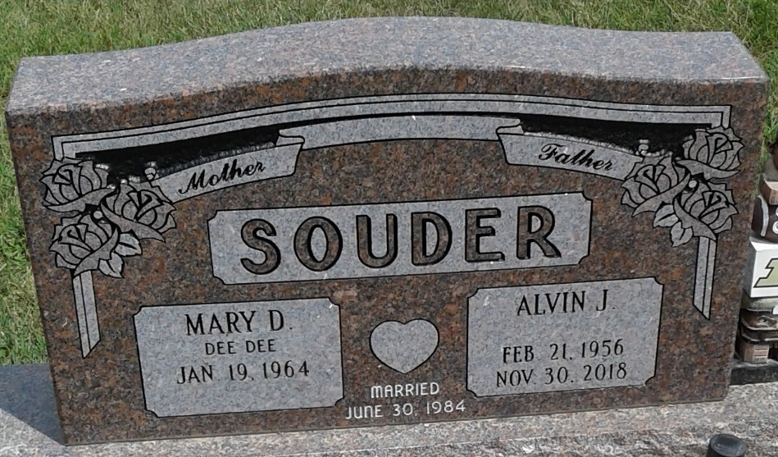
Photo by PLS

