John F. Souder
February 13, 1948 – November 14, 1988

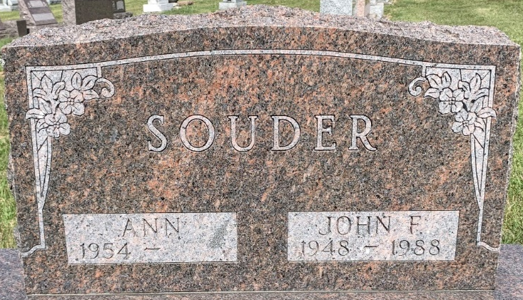
Photo by S Riley

John F. Souder, 40, Cleveland, Tenn., a former Decatur resident, died at 7 a.m. Monday at Bradley County Memorial Hospital from a self-inflicted gunshot wound.
He was a computer programmer for Duracel Corp. for 6 1/2 years, and a former employee of CTS in Berne and Vinnie's Bar in Decatur.
He graduated from Decatur High School in 1966 and received an associate's degree in computer science from Indiana-Purdue, Fort Wayne and his BA degree from Tusculum College in Tennessee.
Born in Decatur on Feb. 13, 1948, he was the son of Franklin and Verdella Everett-Souder, and was married to Ann Bultemeier on June 4, 1977.
Survivors include the wife; a son, Christopher, at home; the mother, Mrs. Verdella Souder, Decatur; and a brother, Alvin Souder, Decatur.
Arrangements are pending at Zwick-Sefton & Jahn Funeral Home.

Decatur Daily Democrat; Adams County, Indiana
Tuesday, November 15, 1988

