Franklin Theodore Souder
November 8, 1916 – December 25, 1985

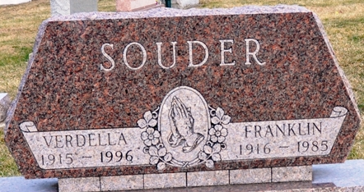
Photo by Deb Curry

Franklin Theodore Souder
in the Indiana, U.S., Death Certificates, 1899-2017
Name Franklin Theodore Souder
Gender Male
Race White
Marital Status Married
Age 69
Birth Date 8 Nov 1916
Birth Place Decatur
Death Date 25 Dec 1985
Death Place Decatur, Adams, Indiana, USA
Death Registration Date 1985
Father Homer Lloyd Souder
Mother Hilda Mae Trenary
Spouse Verdella Everett
Informant Mrs. Verdella Souder; wife; Decatur, Indiana
Burial December 28, 1985; Decatur Cemetery; Decatur, Indiana

