Elizabeth A. (Keller) Souder
December 29, 1959 – August 1, 2007

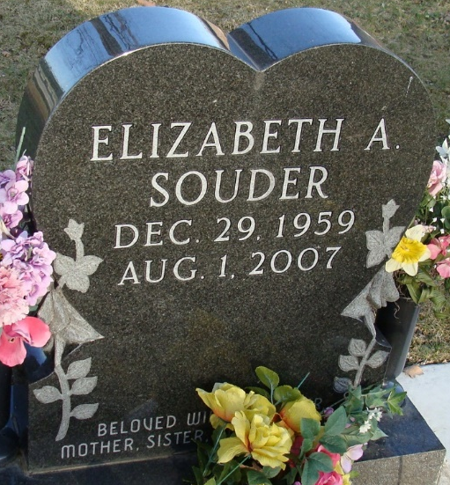
Photo by Alicia Kneuss

Elizabeth A. "Liz" Souder, 47 of Fort Wayne, formerly of Decatur passed away Wednesday, August 1, 2007 at Lutheran Hospital.
She was born in Ft. Leonardwood, MO on December 29, 1959 to Neil & Susan (Heller) Keller. She married Steve Souder on June 24, 2005.
Survivors include her husband Steve Souder of Ft. Wayne; parents Neil & Sue Keller of Decatur, mother-in-law Dolores Souder of Auburn, IN; a son Michael Fick a student at Purdue University in W. Lafayette; a step son Corey Souder of Ft. Wayne, a daughter Mrs. Eric (Tracey) Garner of Decatur; a brother Craig Keller and a sister Jan Gross both of Decatur; and 2 grandmothers Mary Jessup & Bernadine Heller both of Decatur.
Liz was a member of Zion United Church of Christ in Decatur. She was also a member of the Indiana State Teachers Association and the N.E.A. Liz taught for 6 years at Adams Central High School.
Calling hours are from 2-8 pm Friday, August 3, 2007 and 9:30-10:30 am Saturday, August 4, 2007 at Haggard & Sefton Funeral Home.
Funeral service will be at 11:00 am at Zion United Church of Christ. Rev. Jean Carmen will be officiating and burial is in Decatur Cemetery.
Memorials are to the Elizabeth Souder Scholarship Fund.

Haggard & Sefton Funeral Home, Adams County, Indiana
December 30, 1959

