Ann Susan (Bultemeier) Souder
1954 -

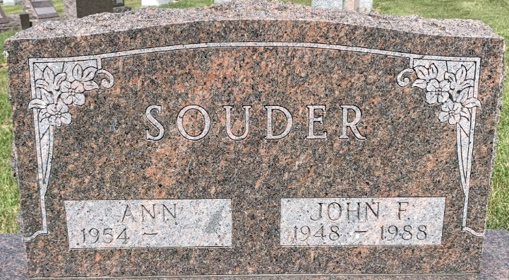
Photo by S Riley

John Franklin Souder
in the Indiana, U.S., Marriage Certificates, 1960-2012
Name John Franklin Souder
Gender Male
Marriage Age 29
Birth Date abt 1948
Birth Place Indiana
Marriage Date 4 Jun 1977
Marriage Place Decatur, Adams, Indiana, USA
Marriage Registration Date 1977
Spouse Ann Susan Bultemeier
Description Adams-Lake
Notes 2 N
Reference Number 1 Bx1449
Reference Number 2 Tr8412
Certificate Number 77-017170

