Alvin J. Souder
February 21, 1956 – November 30, 2018

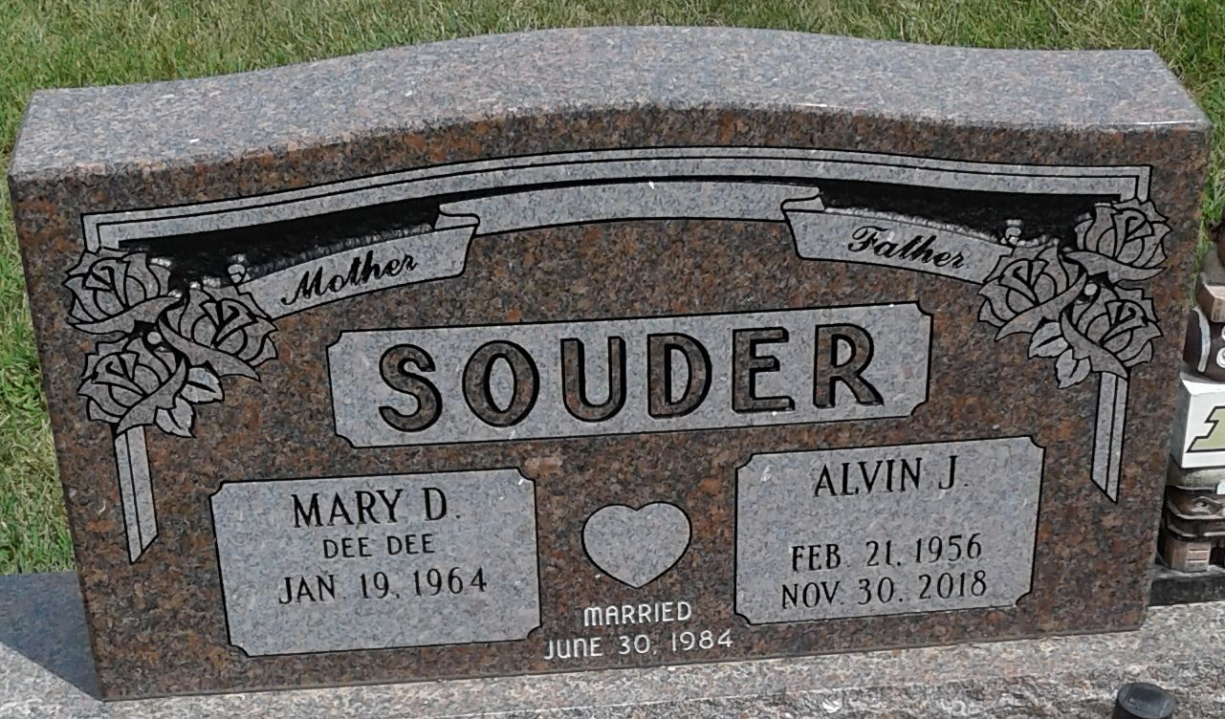
Photo by PLS

Alvin J. Souder, 62, of Decatur, Indiana passed away early Friday morning, November 30, 2018, at Adams Memorial Hospital after suffering a stroke at home. He was born on February 21, 1956 in Adams County, Indiana to Franklin T. and V. Verdella (Everett) Souder. On June 30, 1984, he married Mary D. “Dee Dee” Peterson at St. Mary of the Assumption Catholic Church in Decatur.
Alvin was a lifetime member of the American Rifle Association & a former member of the Elks Lodge #993 in Decatur. He had served as an advisor for Boy Scouts of America.
Alvin was a 1974 graduate of Bellmont High School. He had been employed at All American Homes for 35 years and was currently employed at REV Group in Decatur. Alvin was a hard worker and a friend to all. Because he had a heart for others, Alvin was a tissue donor to help those in need. He enjoyed spending time with his three grandsons. He also enjoyed spelunking (exploring caves) and spending time at Lake James. Alvin spent Sunday mornings with his friends at the Pancake House enjoying coffee and breakfast.
He is survived by his wife, Dee Dee Souder of Decatur; two daughters, Jessica R. (David Roemer) Phillips and Marissa A. Souder both of Decatur; sister-in-law, Ann Souder of Decatur; nephew, Chris Souder of Tampa, FL; his in-laws, John & Sharon Keller of Decatur; and three grandsons, Coltin J. Phillips, Bryson A. McDowell, & Dominic A. McDowell. He was preceded in death by his parents and his brother, John F. Souder.
A funeral service will be held at 11:00 a.m. Monday, December 3, 2018 at Zwick & Jahn Funeral Home in Decatur with Pastor Dan York officiating. Interment will follow at Decatur Cemetery. Family and friends will be received from noon to 2 p.m. and 3 to 6 p.m. Sunday, December 2, 2018 at Zwick & Jahn Funeral Home in Decatur.
Preferred memorials are to his Grandchildren’s Education Fund (checks payable to Dee Dee Souder).

Zwick & Jahn Funeral Home, Adams County, Indiana
December 1, 2018

