Rolando F. Soto
December 8, 1986 – May 14, 2007

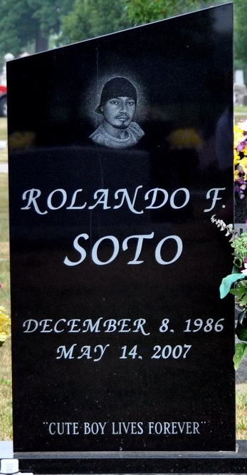
Photo by Deb Curry

Rolando F. Soto, 20 of Decatur died from a traffic accident in Wells County on Monday, May 14, 2007. Rolando was born on December 8, 1986 in Brownsville, Texas to Amado & Maria Oralia (Fernandez) Soto.
Survivors include his parents of Decatur, a brother Jose' A. (Michelle) Soto; 2 sisters Mrs. Jorge (Margarita) Barrientos, Raquel Soto all of Decatur; maternal grandparents Enrique & Eloisa Fernandez of Brownsville, TX.
Calling hours are from 4-8 pm Thursday, May 17, 2007 at Haggard & Sefton Funeral Home with reciting of the Rosary at 8:00 pm. also at the funeral home. There is calling from 9:30-10:30 am Friday, May 18, 2007 at St. Mary of the Assumption Catholic Church followed by a 10:30 Mass of Christian Burial at the church. Father David Voors will be officiating and burial is in Decatur Cemetery.
Memorials are to the Family.

Haggard & Sefton Funeral Home, Adams County, Indiana
May 15, 2007

