Herman J. Sorg
January 12, 1920 – January 22, 1999

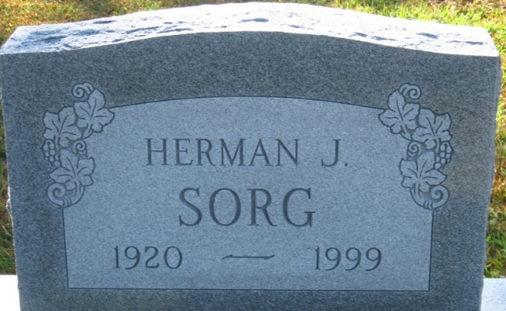
Photo by S Riley

Herman J. Sorg Sr., 79, of Wawaka, a machinist, died Friday, Jan. 22, 1999, at Parkview Hospital. The Detroit native retired in 1982 from Tokheim after 29 years of service and was a member of Moose Lodge 1063 in Columbia City.
Surviving are daughters Carol Moffett and Margaret Heath, both of Fort Wayne; sons Herman J. Jr., Robert Gilbert and Jerry Moffett, all of Fort Wayne; a stepdaughter, Edwina Williamson of Columbia City; a sister, Geraldine Sorg of Fort Wayne; 25 grandchildren; 41 great-grandchildren; and nine great-great-grandchildren. His wife, Agnes L., preceded him in death on Jan. 18.
Services were today at Zwick & Jahn Funeral Home, Decatur. Burial was in Decatur Cemetery.
Memorials are to the donor's choice.

News-Sentinel, Allen County, Indiana
Monday, January 25, 1999

**
Indiana, U.S., Death Certificates, 1899-2017
Name Herman J. Sorg Sr
Gender Male
Race White
Marital Status Widowed
Age 79
Birth Date 12 Jan 1920
Birth Place Detroit, Michigan
Death Date 22 Jan 1999
Death Place Fort Wayne, Allen, Indiana, USA
Death Registration Date 1999
Father Andrew J. Sorg
Mother Catherine Christman
Informant Carol Rose Ann Moffett; daughter; Fort Wayne, Indiana
Burial January 25, 1999; Decatur Cemetery; Decatur, Indiana

