Winifred L. (Mallonee) Sommer
October 4, 1904 – October 8, 1986

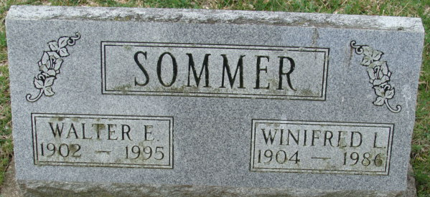
Photo by Alicia Kneuss

Winifred L Sommer
in the Indiana, U.S., Death Certificates, 1899-2017
Name Winifred L Sommer
[Winifred L Mallonee]
Gender Female
Race White
Marital Status Married
Age 82
Birth Date 4 Oct 1904
Birth Place Indiana
Death Date 8 Oct 1986
Death Place Bluffton, Wells, Indiana, USA
Death Registration Date 1986
Father Melvin Mallonee
Mother Nancy Andrews
Spouse Walter E Sommer
Informant Walter Sommer; husband; Decatur, Indiana
Burial October 11, 1986; Decatur Cemetery; Decatur, Indiana

