Walter E. Sommer
December 24, 1902 – February 6, 1995

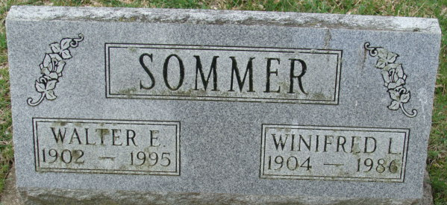
Photo by Alicia Kneuss

Walter Samer
in the Indiana, U.S., Death Certificates, 1899-2017
Name Walter Sommer
Gender Male
Race White
Marital Status Widowed
Age 92
Birth Date 24 Dec 1902
Birth Place Switzerland
Death Date 6 Feb 1995
Death Place Berne, Adams, Indiana, USA
Death Registration Date 1995
Father Abraham Sommer
Mother Louise Flueckiger
Informant Harold M. Sommer; son; Pennsylvania
Burial February 10, 1995; Decatur Cemetery; Decatur, Indiana

