Leonard Allen Soliday
May 27, 1909 – June 4, 1977

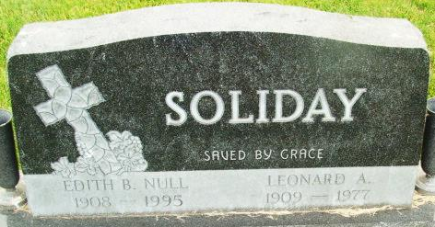
Photo by Alicia Kneuss

Leonard Allen Soliday
in the Indiana, U.S., Death Certificates, 1899-2017
Name Leonard Allen Soliday
Gender Male
Race White
Marital Status Married
Age 68
Birth Date 27 May 1909
Birth Place Iowa
Death Date 4 Jun 1977
Death Place Fort Wayne, Allen, Indiana, USA
Death Registration Date 1977
Father C. E. Soliday
Mother Blanche Sherrick
Spouse Edith B. Null
Informant Mrs. Edith Soliday; wife; Decatur, Indiana

