Robert Lynn Soldner
June 15, 1945 – June 15, 1945

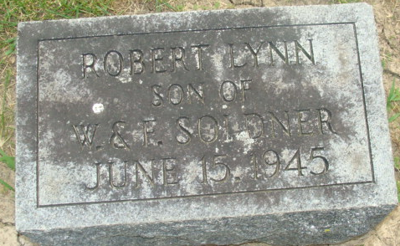
Photo by Alicia Kneuss

Robert Linn Soldner
in the Indiana, Death Certificates, 1899-2011
Name: Robert Linn Soldner
Gender: Male
Race: White
Age: 0
Marital status: Single
Birth Date: 15 Jun 1945
Birth Place: Decatur Adams, Ind
Death Date: 15 Jun 1945; premature
Death Place: Decatur, Adams, Indiana, USA
Father: Weldon L Soldner
Mother: Francis Barkley
Informant: Weldon Soldner; Decatur, Indiana
Burial: June 16, 1945; Decatur Cemetery; Decatur, Indiana

