Waldo Lee Snyder
October 2, 1941 – May 19, 1963

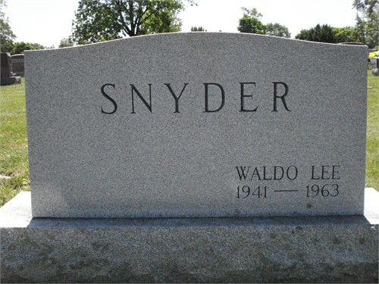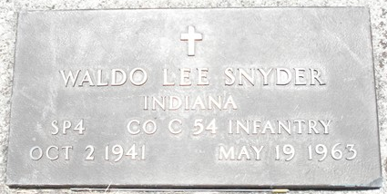
Photo by Deb Curry

Soldier Home On Leave Is Killed Sunday
Waldo Lee Snyder, 21-year-old Decatur soldier home on leave, was killed instantly Sunday afternoon in a one-car crash on U. S. 224, becoming Adams county’s first traffic fatality of 1963.
Snyder died instantly from a crushed chest as a result of being thrown from an auto operated by Elvin Adkins, 21, of 401 W. Adams St., who suffered only bruises and abrasions.
The local young man is the son of Mr. and Mrs. Wilson Snyder, 1304 Master Drive, and had been stationed at Fort Knox, Ky. Since last September.
He had traveled home Tuesday on leave to attend the wedding of his aunt Saturday night and his sister’s graduation Thursday evening.
Both Snyder and Adkins were thrown from the 1957 model car owned by Adkins, as the vehicle went out of control on U. S. 224, five miles east of Decatur.
Dies Instantly
Snyder was killed instantly as he was thrown from the auto. It was believed he struck a flagpole on the Hank Swygart property, causing the crushed chest.
Snyder was a 1960 graduate of Decatur High School, where he was a member of the football and track teams. He entered the U. S. Army following his graduation and served 16 months in Korea.
The first fatal accident of the year in Adams County occurred at 5:09 p.m. as Adkins was traveling west on 224, with Snyder a passenger. Adkins was passing another auto when his car went out of control and traveled more than 200 feet before striking the front step of the sidewalk of the Swygart home.
The underside of the car, under the right door, caught the sidewalk, and caused the vehicle to flip over on its top and slide 81 feet in that position.
Still Investigating
According to the investigating officers, the fatal crash is still under investigation The accident occurred on dry pavement, just a short time before an afternoon shower fell.
Adkins suffered only minor injuries but is being held in the Adams County Memorial Hospital today. His automobile was a total loss.
Sheriff Roger Singleton, deputy Sheriff Harold August and state trooper Dan Kwasneski investigated the fatal crash.
Services Wednesday
Funeral services for Snyder will be held at 2 p.m. Wednesday at the Zwick funeral home, with the Rev. Robert Crabtree officiating. Friends may call at the funeral home after 7 o’clock this evening.
Surviving the young soldier are the parents, Wilson and Fluorine Bollinger Snyder; one sister, Evelyn Dale Snyder; one brother, James Arllie?? Snyder; the maternal grandmother, Mrs. Luna Snyder of Fort Wayne; and the paternal grandparents, Mr. and Mrs. Arllie?? G. Bollinger, 925 Dierkens St.
Snyder was born October 2, 1941 and attended the Assembly of God church in Decatur.

Berne Library Heritage Room, Adams County, Indiana
1962 – 1964 Obits
Handwritten date: Monday May 20, 1963
**
Indiana, U.S., Death Certificates, 1899-2017
Name Waldo Lee Snyder
Gender Male
Race White
Marital Status Never Married (Single)
Veteran Yes
Age 21
Birth Date 2 Oct 1941
Birth Place Indiana
Death Date 19 May 1963; auto accident
Death Place Decatur, Adams, Indiana, USA
Death Registration Date 1963
Father Wilson Snyder
Mother Florine Bollinger
Informant Wilson Snyder; father; Decatur, Indiana
Burial May 22, 1963; Decatur Cemetery; Decatur, Indiana

