Thomas Franklin Snyder
September 15, 1876 - 1936

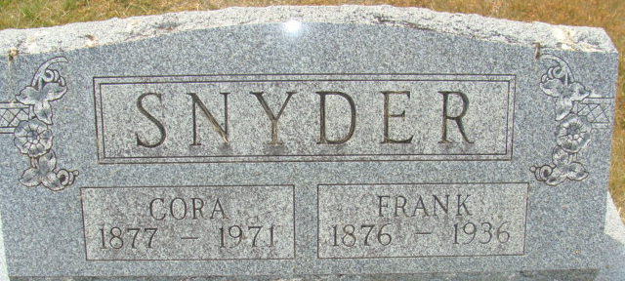
Photo by Alicia Kneuss

Thomas Franklin Snyder from tree Smith Family Tree
Birth 15 Sep 1876 Mercer, Ohio, USA
Marriage 1897
Residence 1930 Fort Wayne, Allen, Indiana, USA
Death 1936 Canton, Stark, Ohio, USA
Father Jacob Snyder
Mother Rachel Wolfkale
Spouse Cora Higgens (1877-1971)

