Raymond H. Snyder
January 26, 1907 – October 20, 1995

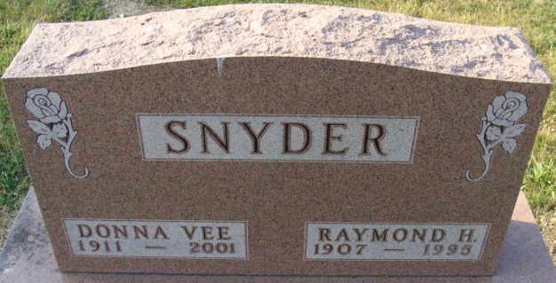
Photo by Alicia Kneuss

Raymond H Snyder
in the Indiana, U.S., Death Certificates, 1899-2017
Name Raymond H Snyder
Gender Male
Race White
Marital Status Married
Age 88
Birth Date 26 Jan 1907
Birth Place Adams County, Indiana
Death Date 20 Oct 1995
Death Place Bluffton, Wells, Indiana, USA
Death Registration Date 1995
Father Charles Snyder
Mother Anna Neeman
Spouse Donna V Weaver
Informant Donna V. Snyder; wife; Berne, Indiana
Burial; October 23, 1995; Decatur Cemetery; Decatur, Indiana

