Judy Kay Snyder
April 2, 1946 – April 2, 1946

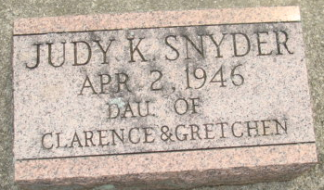
Photo by Alicia Kneuss

Judy Kay Snyder from tree Snyder, Family Tree Denise
Birth 1946
Death 1946
Father Clarence Lamoille Snyder (1913-1988)
Mother Gretchen I Buckingham (1918-2004)

