Jeffrey L. Snyder
February 17, 1952 – April 25, 2019

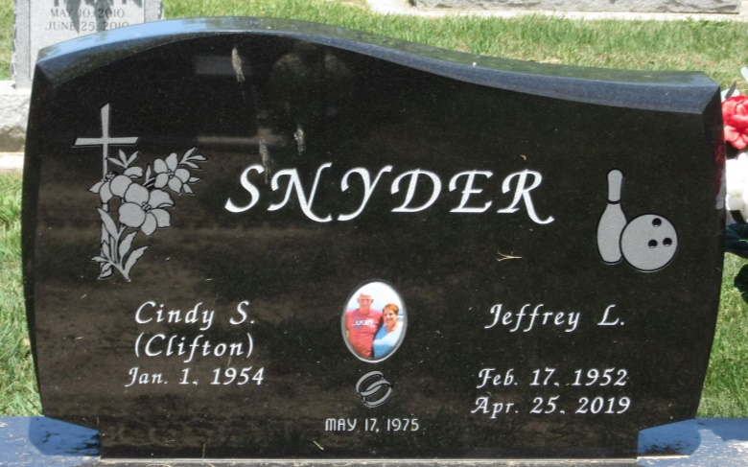
Photo by PLS

Jeffrey L. Snyder, 67, of Geneva passed away Thursday, April 25, 2019 at Lutheran Hospital. Jeff was born in Decatur on February 17, 1952 to the late Leon D. and Mary R. (Pollock) Snyder. On May 17, 1975; Jeff married Cindy S. Clifton.
Jeff attended the Bridge Community Church South in Berne. He was a 1971 Bellmont High School graduate. Jeff was employed at Bunge for 47 years, presently a grain loader in the elevator; he was also a union member of the United Steele Workers Union 15173.
Jeff is survived by his wife of 43 years, Cindy S. Snyder of Geneva; a son, Cory (Jacqueline) Snyder of Lafayette, grandson Beau; a daughter, LeeAnn (James) Miller of Geneva, grandsons, Maddox, Brogan, granddaughter Harper and one on the way, baby girl to arrive in May; 4 siblings, Beth Ann (J.C.) Ford of Van Wert, OH, Deb (Ken) Heyerly of Decatur, Mike (Connie) Snyder of Decatur and Jo (Jay) Witte of Decatur.
Visitation will be held on Monday, April 29, 2019 from 1:30-4:00 p.m. and 5:00-7:00 p.m. at Haggard-Sefton-Hirschy & Zelt Funeral Home. In honor of Jeff, his preference would be for everyone to be casually dressed in sports attire at the visitation.
Funeral services will be held at 11:00 a.m. Tuesday, April 30th at the Bridge Community Church South in Berne, with calling 1 hour prior to service from 10:00-11:00 a.m. Officiating will be Eric Lehman. Burial will be in Decatur Cemetery.
In Lieu of flowers, memorials may be given to the Grandchildren’s Education Fund.

Haggard & Sefton Funeral Home, Adams County, Indiana
Thursday, April 25, 2019

