Gretchen E. (Buckingham) Snyder
December 15, 1918 – December 1, 2004

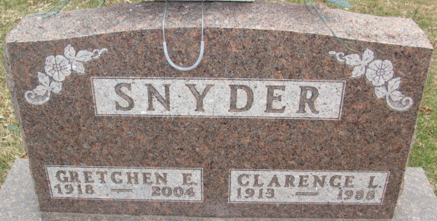
Photo by Alicia Kneuss

Gretchen E Snyder
in the Indiana, U.S., Death Certificates, 1899-2017
Name Gretchen E Snyder
[Gretchen E Buckingham]
Gender Female
Race White
Marital Status Widowed
Age 85
Birth Date 15 Dec 1918
Birth Place Jay County, Indiana
Death Date 1 Dec 2004
Death Place Decatur, Adams, Indiana, USA
Death Registration Date 2004
Father Harry Buckingham
Mother Myrtle Fenters
Informant Karen Rowdon; daughter; Fort Wayne, Indiana
Burial December 4, 2004; Decatur Cemetery; Decatur, Indiana

