Gorden Lee Snyder
July 14, 1939 – March 30, 1995

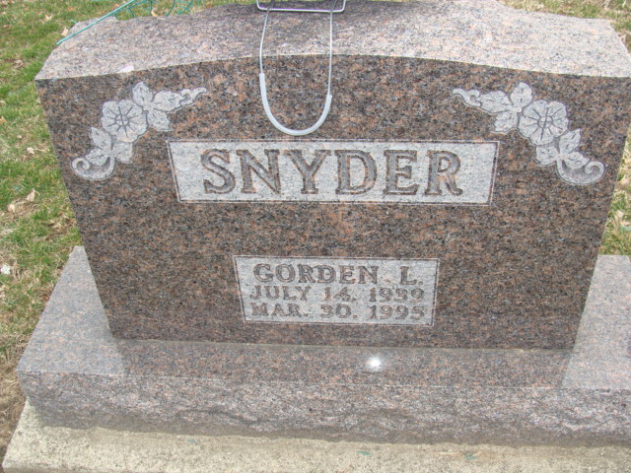
Photo by Alicia Kneuss

Gorden L. Snyder, 55, 747 E. Monroe St., died at 9:15 a.m. Thursday in Medical Center Hospital at Marion, Ohio after suffering a stroke.
He was born on July 14, 1939 in Adams County to Clarence and Gretchen Buckingham Snyder. His father is deceased; his mother lives in Decatur.
He was a truck driver for Prestress Services of rural Decatur for 16 years and was a member of Bass Masters and Zion United Church of Christ in Decatur.
Other survivors are three sons, Darin L., Darrick L., and Duane L. Snyder, all of Decatur; two daughters, Dawn L. and Denise L. Snyder, both of Decatur; three sisters, Mrs. William (Karen) Rowdon, Fort Wayne; Mrs. Ron (Jacie) Ford, Spring Lake, Michigan; and Mrs. Scott (Debra) Anderson, College Station, Texas; his ex-wife, Sharon K. Whittenbarger-Snyder, Decatur; and a grandchild. A granddaughter is deceased.
Funeral services will be at 2 p.m. Sunday in Haggard and Armes Funeral Home, Decatur, with burial in Decatur Cemetery. Visiting hours are 2-5 and 7-9 p.m. Saturday. Preferred memorials are to the American Diabetes Association.

Berne (IN) Library Heritage Room - Misc obits
Unknown newspaper clipping
Handwritten-March 1995 [died March 30, 1995]
**

U.S., Social Security Applications and Claims Index, 1936-2007
Name Gorden Lee Snyder
[Gorden L Snyder]
Gender Male
Race White
Birth Date 14 Jul 1939
Birth Place New Corydon, Indiana
Death Date 30 Mar 1995
Father Clarence L Snyder
Mother Gretchen E Buckingham
SSN xxx
Death Certificate Number HAGGARD AND ARMES
Notes Jul 1955: Name listed as GORDEN LEE SNYDER; 14 Apr 1995: Name listed as GORDEN L SNYDER

