Donna Vee (Weaver) Snyder
December 12, 1911 – August 17, 2001

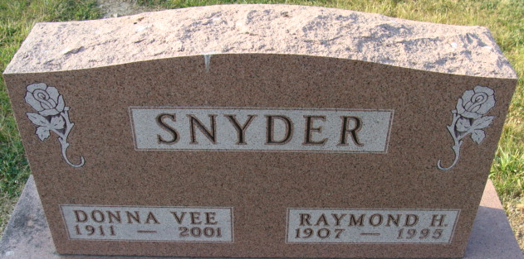
Photo by Alicia Kneuss

Donna V Snyder
in the Indiana, U.S., Death Certificates, 1899-2017
Name Donna V Snyder
[Donna V Weaver]
Gender Female
Race White
Marital Status Widowed
Age 89
Birth Date 12 Dec 1911
Birth Place Geneva, Indiana
Death Date 17 Aug 2001
Death Place Columbia, Whitley, Indiana, USA
Death Registration Date 2001
Father Tilden Weaver
Mother Bertha Buckey
Informant Mrs. Mary Beth Pepple; daughter; Columbia City, Indiana
Burial August 21, 2001; Decatur Cemetery; Decatur, Indiana

