Cora (Higgins) Snyder
December 27, 1877 – December 8, 1971

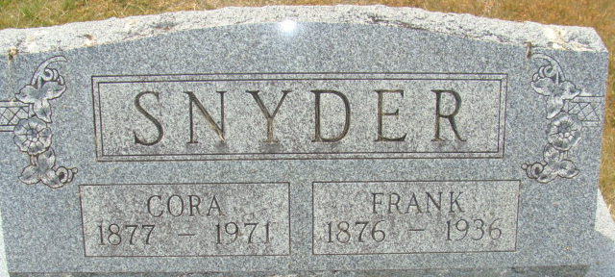
Photo by Alicia Kneuss

Cora Snyder, 93 Dies in Florida
Mrs. Cora Snyder, 93, of St. Petersburg, Fla., a former resident of Decatur, died at 8:50 p.m. Wednesday at her home following an extended illness. She had resided in Florida since 1933.
Born in Wells County Dec. 27, 1877, she was a daughter of William and Margaret Higgins and was married to T. Frank Snyder Nov. 4, 1896. Her husband preceded her in death Aug. 13, 1936.
Mrs. Snyder was a member of the Unity Church at Tampa, Fla.
Surviving are two daughters, Mrs. R.W (Nola) Loose of St. Petersburg, and Mrs. Herbert (Lillian) Hattendorf of Tampa, Fla.; two sisters, Mrs. John Neff and Mrs. Morris McCray, both of Bluffton; nine grandchildren; six great-grandchildren and two great-great-great-grandchildren. One daughter, Mrs. Florence Schnitz, formerly of Decatur; two sons, two sisters and two brothers are deceased.
The body will be brought to Decatur for funeral services at 2 p.m. Sunday at the Zwick Funeral Home, with Rev. Fuhrman H. Miller officiating. Burial will be in the Decatur Cemetery. Friends may call at the funeral home after 2 pm. Saturday until time of the services.
Decatur Daily Democrat, Adams County, Indiana
Thursday, December 9, 1971

