Clarence L. Snyder
May 1, 1913 – September 22, 1988

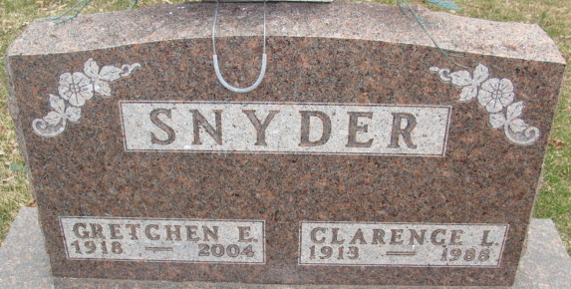
Photo by Alicia Kneuss

Clarence L Snyder
in the Indiana, U.S., Death Certificates, 1899-2017
Name Clarence L Snyder
Gender Male
Race White
Marital Status Married
Age 75
Birth Date 1 May 1913
Birth Place Adams County, Indiana
Death Date 22 Sep 1988
Death Place Decatur, Adams, Indiana, USA
Death Registration Date 1988
Father Charles Snyder
Mother Anna Neman
Spouse Gretchen Buckingham
Informant Gretchen Snyder; wife; Decatur, Indiana
Burial September 25, 1988; Decatur Cemetery; Decatur, Indiana

