Cindy S. (Clifton) Snyder
January 1, 1954 -

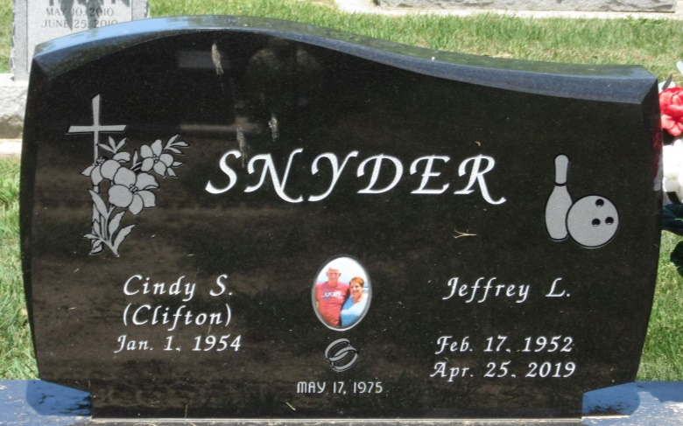
Photo by PLS

