Jennie E. (Miller) Snider
September 7, 1890 – March 19, 1986

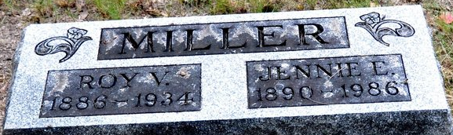
Photo by Deb Curry

Jennie E Snider
in the Indiana, U.S., Death Certificates, 1899-2011
Name: Jennie E Snider
[Jennie E Miller]
Gender: Female
Race: White
Age: 95
Marital status: Widowed
Birth Date: 7 Sep 1890
Birth Place: Ohio
Death Date: 19 Mar 1986
Death Place: New Haven, Allen, Indiana, USA
Father: Jacob R Miller
Mother: Sophia E Strain
Informant: Jack Fisher; cousin; Fort Wayne, Indiana
Burial: March 21, 1986; Decatur Cemetery; Decatur, Indiana

