Jason Lynn Snider
May 28, 1981 – May 28, 1981

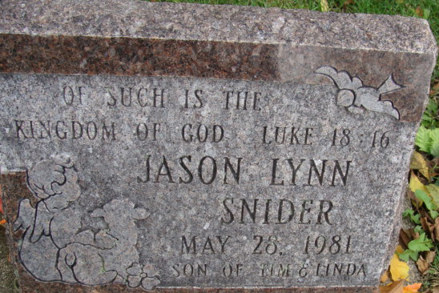
Photo by Alicia Kneuss

Jason Lynn Snider
in the Indiana, U.S., Death Certificates, 1899-2017
Name Jason Lynn Snider
Gender Male
Race White
Age 3 hours
Birth Date 28 May 1981
Birth Place Indiana
Death Date 28 May 1981
Death Place Fort Wayne, Allen, Indiana, USA
Death Registration Date 1981
Father Timothy Snider
Mother Linda Winans
Informant Timothy Snider; father; Decatur, Indiana
Burial May 30, 1981; Decatur Cemetery; Decatur, Indiana

