Thomas Val Snell
November 17, 1950 – September 7, 1994

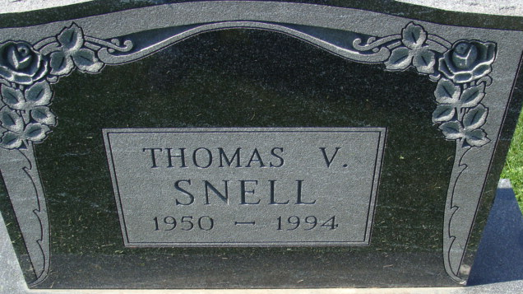
Photo by Alicia Kneuss

THOMAS V. SNELL
Thomas V. Snell, 43, Indianapolis, a former Decatur resident died at 12:30 a.m. today in St. Vincent Hospital, Indianapolis. Mr. Snell, a consultant with Data Processing Management Company in Indianapolis, was a member of St. Mark's United Methodist Church.
He was born in Decatur on November 17, 1950 to Clement F. Snell and Madeline R. (Spahr) Snell. His father is deceased.
Survivors include his mother of Decatur, and a brother David F. Snell of Marion.
Funeral services are at 11 a.m. Saturday at Haggard & Armes Funeral Home. Burial will follow in Decatur Cemetery. Visiting hours are 2-5 p.m. and 7-9 p.m. Friday.
Memorials are to St. Mark's United Methodist Church or the Adams County Chapter of the American Heart Association.

Decatur Daily Democrat, Adams County, Indiana
Wednesday, September 7, 1994

