Madeline R. (Spahr) Snell
June 13, 1917 – July 27, 2000

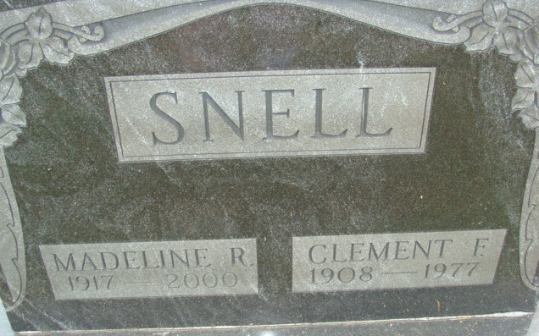
Photo by Alicia Kneuss

Madeline R Snell, 83, Marion, a former longtime Decatur resident, died at 8:08 a.m. Thursday in Bradner Village Health Care Center.
She was born on June 13, 1917, in Markle to John C. and Edna M. Foor Spahr and married Clement F Snell on November 28, 1946; he died on July 15, 1977.
She retired in 1979 after a career as a teacher in Adams County.
She was a member of St. Marks United Methodist Church in Decatur, the United Methodist Women, the Shakespeare Club, the honorary chapter of Psi Iota Xi Sorority, and the Retired Teachers Association. She was also a former member of the Decatur Library Board and a member of the Adams County Memorial Hospital Auxiliary for 14 years.
Surviving are a son, David F. Snell of Marion; a sister, Evangeline Lee of Cuyahoga Falls, Ohio; four grandchildren and two greatgrandchildren. A son, Thoms V. Snell, died on September 7, 1994, and a sister, Mary Gennig and two brothers, John and William Spahr, are also deceased.
Funeral services will be held at 2 p.m. Sunday in Haggard and Sefton Funeral Home, Decatur, with burial in Decatur Cemetery. Visiting hours are 2 to 4 and 6 to 8 p.m. Saturday.
Preferred memorials are to the church or to the Adams County Heart Club.

Decatur Daily Democrat, Adams Co, Indiana
Friday, July 28, 2000

