Clement F. Snell
January 27, 1908 – July 15, 1977

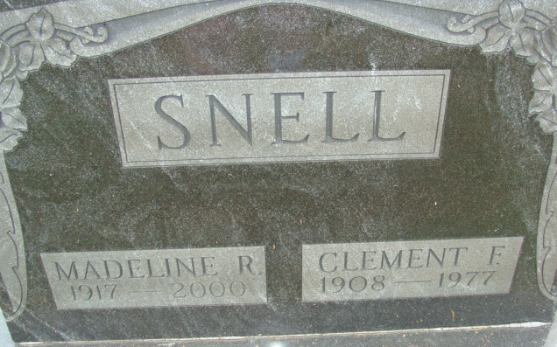
Photo by Alicia Kneuss

Clement F. Snell, 69, of 822 North Third St., a retired General Electric employee died unexpectedly at 5:10 a.m. today at his home. He retired from GE in January of 1970 after 28 years of service.
Mr. Snell was a member of the St. Mark's United Methodist church, American Legion, Moose Lodge, Elks Lodge, GE Quarter Century Club, and a veteran of World War II.
Born in Adams County on January 27, 1908, he was the son of Val and Irilla Russell Snell, and was united in marriage on November 28, 1946, to Madeline R. Spahr, who survives.
Also surviving are two sons, David F. Snell, Marion; Thomas V. Snell, Fort Wayne; [sisters] Mrs. Frank (Francis) Bohnke, Decatur; Mrs. Rose Sorlie, Fort Wayne; Mrs. Elmer (Lilly) Beineke, Fort Wayne; and one granddaughter, Amy Lynn Snell. One sister preceded him in death.
Funeral services will be conducted Monday at 10 a.m. at the Winteregg-Linn & Haggard Funeral Home, with Rev. C. Albert Nunery officiating. Burial will be in the Decatur Cemetery. Friends may call at the funeral home after 7 p.m. Saturday. Moose memorial services will be held at 7:30 p.m. Sunday.
Preferred memorials are to the St. Mark's United Methodist Church.

Decatur Daily Democrat, Adams Co, Indiana
Friday, July 15, 1977

