Amanda W. (Bieberich) Snell
August 2, 1914 – August 17, 1945

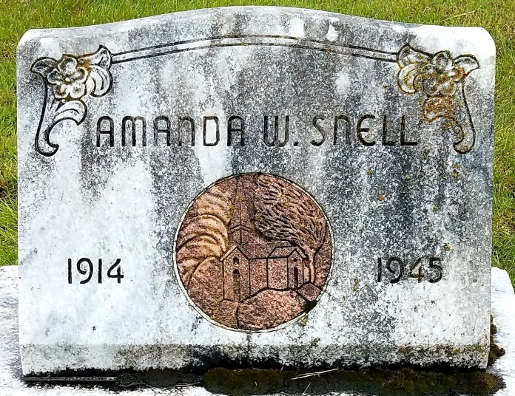
Photo by Deb Curry

Mrs. Amanda Snell Dies Friday Night
Funeral Services Tuesday Afternoon

Mrs. Amanda Snell, 31, lifelong resident of Adams County died at 10:30 o'clock Friday night at the Adams County Memorial Hospital, where she had been a patient for the past two weeks. Death was attributed to leukemia.
Her husband, T/4 Clement F. Snell, is stationed with the United States Army in France.
She was born in Kirkland Township August 2, 1914, the daughter of Otto D. and Caroline Kirchner-Bieberich. She was married February 17, 1940, at Bellview, Ky.
Mrs. Snell was a member of the Zion Lutheran Church and was employed at the G. E. plant until ill health forced her retirement.
She is survived by the husband, the parents, and the following brothers and sisters: Oscar Bieberich of Magley, Mrs. Martha Hilpert of near Decatur, T/Sgt. Henry of Camp Blanding, Fla., Pfc. Carl, with the Army in Manila, Mrs. Catherine Cauble of Kirkland Township, Mrs. Della Cox of PoEll, Washington, D. C. and Miss Mary Bieberich, at home.
Funeral services will be held at 1:30 p. m. Tuesday at the Zwick Funeral Home and at 2 o'clock at the church, with the Rev. Karl Hofmann officiating. Burial will be in the Decatur Cemetery. Friends may call at the funeral home after 2 p. m. Sunday.

Adams County Historical Museum, Adams County, Indiana
1945A Scrapbook, image 73-78
Handwritten Date: August 18, 1945

