William A. Smitley
April 7, 1883 – April 11, 1970

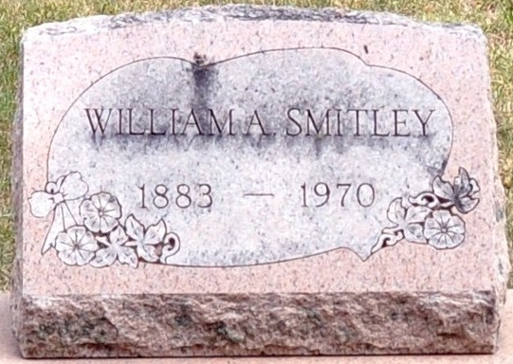
Photo by Deb Curry

William Smitley Dies Here Saturday
William Smitley, 87, of 228 Madison Street, a retired blacksmith, ws dead on arrival at 8:40 a.m. Saturday at the Adams County Memorial Hospital. He had been ill for two years.
He was born in Blue Creek Township, April 7, 1883, a son of Nelson and Mary Foreman-Smitley.
Surviving is one son, Kenneth Smitley of Flint, Mich.; a sister, Mrs. Blanche Applebee of Flint, Mich.; one brother, Roy Smitley of Bradenton, Fla.; and a number of nieces and nephews.
Funeral rites will be held at 10 a.m. Tuesday at the Winteregg-Linn Funeral Home, with Rev. Vernon Riley officiating. Burial will be in the Decatur Cemetery. Friends may call at the funeral home until time of the services.

Decatur Daily Democrat, Adams County, Indiana
Monday, April 13, 1970

