Joanna H. (Daily) Smitley-Warfel
November 29, 1919 – October 6, 1993

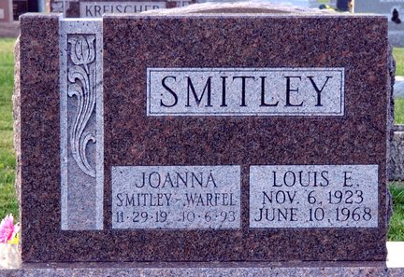
Photo by Deb Curry

Joanna H. Warfel, 73, of Decatur died Wednesday in Adams County Memorial Hospital. The Adams County native was the widow of Joe Poffenberger, Louis E. Smitley and Frederick W. Warfel. She also was Adams County Recorder 1969-1977 and former owner of Das Blumenhaus in Berne.
Surviving are a daughter, Cheri Scherry of Decatur, son, Ronald Smitley of Decatur; sister, Jane Mead of Fort Wayne; and six grandchildren.
Services are 11 a.m. tomorrow in Haggard & Armes Funeral Home, Decatur, where calling is 2 to 9 p.m. today, and 9 to 11 a.m. tomorrow. Burial will be in Decatur Cemetery.
Preferred memorials are gifts to Adams County Council on Aging.

News-Sentinel, Allen County, Indiana
October 8, 1993
**
JOANNA H. WARFEL
Former Adams County Recorder Joanna H. Warfel, 73, 746 Woodlynn Dr., an ex-resident of Berne, died on Wednesday in Adams County Memorial Hospital.
A Democrat, she was elected to two straight terms as county recorder (1969-77) and served as deputy recorder under recorders Rosie Spangler Williams and Barbara Kershner. Mrs. Warfel was also a co-owner and co-operator of Das Blumenhaus in Berne for a number of years.
She was born on November 29, 1919 in Adams County to Augustus and Marie Sprunger Daily and was married three times. Her first husband, Joe Poffenberger, was killed during World War II. Her second husband, Louis E. Smitley, whom she married on March 6, 1947, died on June 10, 1968. Her third husband, Frederick W. Warfel, whom she married on August 21, 1969, died on July 14, 1989.
She was a member of Cross United Church of Christ in Berne, Democratic Women's Club, American Legion Auxiliary, the board of directors of Adams County Council on Aging, and Gamma Nu Sorority.
Surviving are one son, Ronald Smitley, Decatur; one daughter, Mrs. Wayne (Cheri) Scherry, Decatur; one sister, Jane Mead, Fort Wayne; and six grandchildren.
Funeral services will be at 11 a.m. Saturday in Haggard and Armes Funeral Home, Decatur, with Rev. Mark Steiner officiating. Burial will be in Decatur Cemetery. Visiting hours will be from 2-9 p.m. Friday and 9-11 a.m. Saturday in the funeral home.
Preferred memorials are to the Adams County Council on Aging.

Adams County, Indiana Public Library
Obit book #9, page 161
Handwritten date: Thursday, October 7, 1993

