Thomas Russell Smitley
July 30, 1914 – January 30, 1974

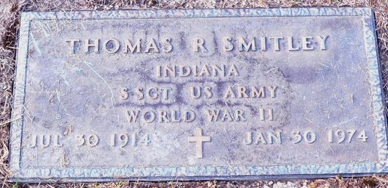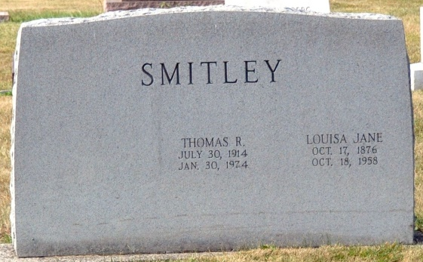
Photo by Deb Curry

Thomas Russell Smitley Dies; Rites are Saturday
Thomas Russell Smitley, 59, of route 3, Decatur, a welder, died at 3:15 p.m. Wednesday at his residence. Death was attributed to a heart attack. Mr. Smitley, a member of Jehovah’s Witnesses, was a veteran of World War II.
Born in Decatur on July 30, 1914, he was a son of George and Louisa Jane Clark-Smitley, and was never married.
Survivors include one sister, Mrs. Phillip (Kathryn) Baker of route 3, Decatur; and several nieces and nephews. One sister and three brothers preceded him in death.
Funeral services will be held at 1:30 p.m. Saturday at the Winteregg-Linn and Haggard Funeral Home, with Clyde Steele officiating. Burial will be in the Decatur Cemetery. Friends may call at the funeral home after 4 p.m. Friday.

Decatur Daily Democrat, Adams County, IN
Thursday, January 31, 1974

