Sylvia A. (Chronister) Smitley
July 23, 1889 – February 14, 1956

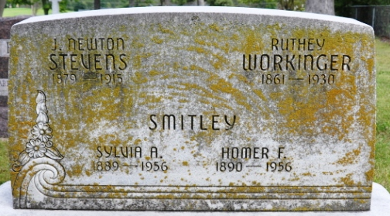
Photo by Deb Curry

WIFE OF HOMER SMITLEY IS DEAD
Services Thursday for 66-Year-Old Decatur Woman

Mrs. Homer Smitley, 66, a native of Adams County, and a life-long resident of the county, died at 12:20 p.m. yesterday in the Adams County Memorial Hospital.
She had been ill for approximately a year, and seriously ill one week. Mrs. Smitley was a member of the Bethany Evangelical United Brethren Church at Decatur.
Surviving are her husband; three daughters, Mrs. Charley Ward and Mrs. Ward Bowman, Decatur, and Mrs. Doyle E. Gilbert, Monroe; a son, Dale Smitley, Kokomo; three stepdaughters, Mrs. John Stauffer, Bluffton and Mrs. Thelma Kistler and Mrs. Donald Snell, Fort Wayne; a stepson, Gerald Smitley, Duncan Falls, Ohio; nine grandchildren and five great-grandchildren.
The body is at the Gillig & Doan Funeral Home, where friends may call after 2 p.m. today. Services will be conducted Thursday at 1:30 p.m. in the funeral home and at 2 o'clock in the Bethany Evangelical United Brethren Church, the Rev. Benjamin C. Thomas and the Rev. H. J. Welty officiating. Burial will be in the Decatur Cemetery.

The Berne Witness; Adams County, Indiana
Wednesday, February 15, 1956

**
Mrs. Homer Smitley Is Taken By Death
Funeral Services Thursday Afternoon

Mrs. Sylvia A. Smitley, 66, wife of Homer Smitley of 421 South First Street, died at 12:20 o’clock Tuesday afternoon at the Adams County Memorial Hospital. She had been ill for years with complications, and her condition had been serious for the past week.
She was born in Adams County July 23, 1889, a daughter of Mr. and Mrs. Joseph T. Chronister, and was married to Homer Smitley in June, 1928.
Mrs. Smitley was a member of the Bethany Evangelical United Brethren Church.
Surviving in addition to her husband are three daughters, Mrs. Charley Ward and Mrs. Ward Bowman of Decatur, and Mrs. Doyle E. Gilbert of near Monroe; a son, Dale Smitley of Kokomo; three stepdaughters, Mrs. John Stauffer of Bluffton, Thelma Kistler and Mrs. Donald Snell of Fort Wayne; a stepson, Gerald Smitley of Duncan Falls, O.; nine grandchildren and five great-grandchildren.
Funeral services will be conducted at 1:30 p.m. Thursday at the Gillig & Doan Funeral Home and at 2 p.m. at the Bethany Evangelical United Brethren Church, the Rev. Benj. G. Thomas and the Rev. H. J. Welty officiating. Burial will be in the Decatur Cemetery. Friends may call at the funeral home until time of the services.

Decatur Daily Democrat, Adams County, Indiana
Wednesday, February 15, 1956

**
The last will and testament of Sylvia Smitley has been offered and accepted for probate and a bond in the sum of $6,000 has been submitted. Homer Smitley has been named executor. The will bequeaths one third of the estate to the husband and the remaining two thirds to three daughters and a son.

The Berne Witness; Adams County, Indiana
Wednesday, February 29, 1956

**
Family Search Record - Indiana Marriages
groom: Joseph T Palmer; groom's race: White
groom's date of birth: 02 Mar 1881; , Adams, Indiana
groom's residence: Decatur, , Indiana
groom's number of marriage: 2nd
groom's father: Thomas Palmer; groom's mother: Louisa Paunt
bride: Sylvia Stevens; bride's race: White
bride's date of birth: 23 Jul 1889; Union, Adams, Indiana
bride's residence: Decatur, , Indiana
bride's number of marriage: 2nd
bride's father: Joseph Chronister; bride's mother: Ruth Drake
date of license: 07 Sep 1918; date of marriage: 07 Sep 1918
place of marriage: , Adams, Indiana
digital folder number: 4186028; number of images: 1

