Ruth E. (Brown) Smitley
September 21, 1905 – December 15, 1982

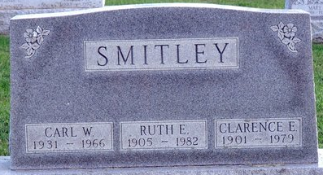
Photo by Deb Curry

Ruth E. Smitley
in the Indiana, U.S., Death Certificates, 1899-2017
Name Ruth E. Smitley
[Ruth E. Brown]
Gender Female
Race White
Marital Status Widowed
Age 77
Birth Date 21 Sep 1905
Birth Place Illinois
Death Date 15 Dec 1982
Death Place Fort Wayne, Allen, Indiana, USA
Death Registration Date 1982
Father Clarence A. Brown
Mother Martha E. Starkey
Informant Robert Smitley; Decatur, Indiana
Burial December 17, 1982; Decatur Cemetery; Decatur, Indiana

