Rosita Joan (Osborne) Egley-Smitley
March 13, 1939 – June 13, 1994

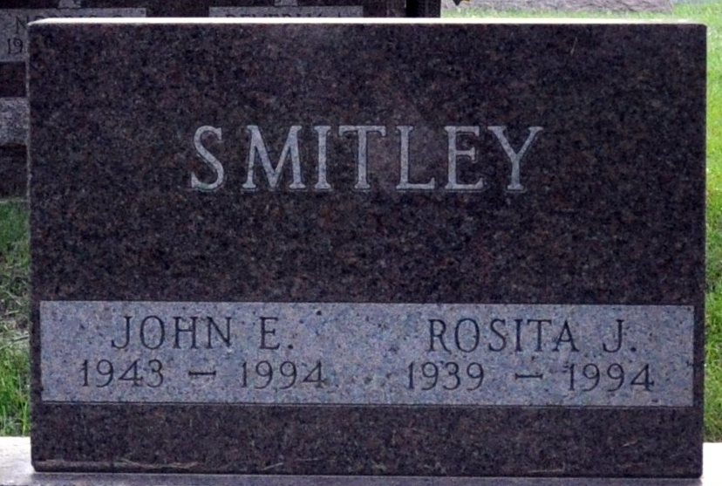
Photo by Deb Curry

Rosita Joan Osborne
in the U.S., Social Security Applications and Claims Index, 1936-2007
Name Rosita Joan Osborne
[Rosita Joan Egley]
[Rosita Smitley]
Gender Female
Race White
Birth Date 13 Mar 1939
Birth Place Chicago, Illinois
Death Date 13 Jun 1994
Father Delbert Osborne
Mother Ollie F Dowacter
SSN xxx
Death Certificate Number ZWICK SEFTON JAHN FH
Notes Aug 1954: Name listed as ROSITA JOAN OSBORNE; Sep 1955: Name listed as ROSITA JOAN EGLEY; May 1968: Name listed as ROSITA JOAN SMITLEY; 18 Jun 1994: Name listed as ROSITA J SMITLEY

