Pamela S. (Dyer) Smitley
May 12, 1966 -

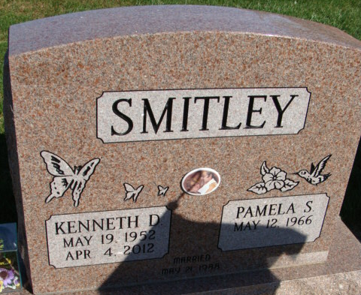
Photo by Alicia Kneuss

