Norma J. (Vorhees) Smitley
November 7, 1931 – September 8, 1990

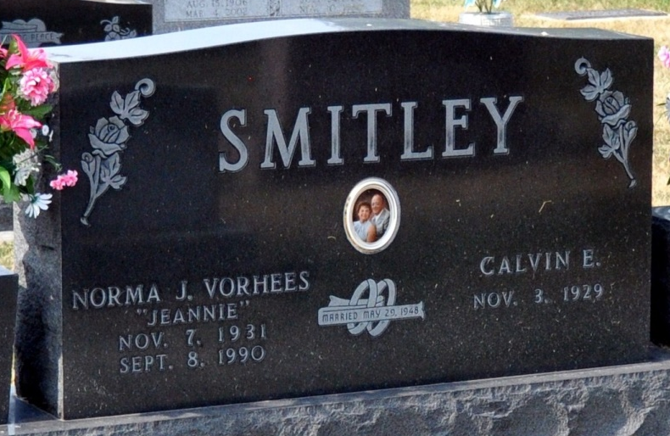
Photo by Deb Curry

NORMA J. SMITLEY
Norma J. Smitley, 58, 812 Bush St., died suddenly at 12:24 a.m. today in Adams County Memorial Hospital. The native of Mercer County, Ohio, married Calvin E. Smitley on May 29, 1947; he survives.
Other survivors are a son, Kenneth D. Smitley, 404 Meadow Lane; three daughters, Mrs. Everett (Nancy) McLeland, route 1, Decatur; Mrs. Michael (Carla) Rapp, 927 Walnut St., and Mrs. Richard (Gayla) Whitman, 325 N. 11 St.; two brothers, Virgil and Jack Vorhees, both of Celina, Ohio; five sisters, Mrs. Ed (Onalee) Myers, Lansing, Michigan; Mrs. Bud (Pat) Shivley, Convoy, Ohio; Mrs. Robert (Helen) Sneddon and Irene Goodpaster, both of Celina; and Mrs. Michael (Karen) Bryant, Bridgman, Michigan; 11 grandchildren; and one great-grandchild. Two sisters, Dottie West and Betty Huston, and one grandson, Samson Rapp, are deceased.
Funeral services are at 1 p.m. Monday in Haggard and Armes Funeral Home, Rev. Fuhrman Miller officiating. Burial will be in Decatur Cemetery. Visiting hours are 2-5 and 7-9 .m. Sunday.
Decatur Daily Democrat, Adams County, Indiana
September 8, 1990

