Marshall Smitley
December 23, 1903 – March 5, 1960

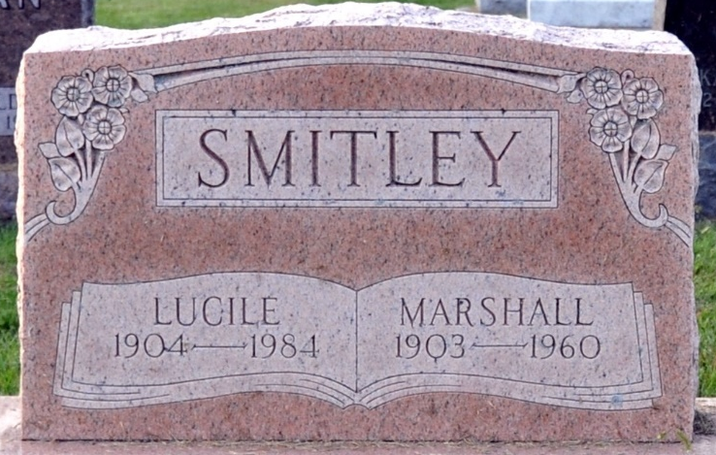
Photo by Deb Curry

SMITLEY BURIAL TO BE AT PHOENIX

Word was received here late Saturday of the death of Marshall Smitley, 59, at the home of his son, in Phoenix, Ariz., after suffering a heart attack.
The Smitleys, who reside at Big Cedar Lake, had gone to Phoenix to visit their sons, George and Bruce. Mr. Smitley's death occurred about 4 p.m. Saturday.
A former Fort Wayne resident, he had been an employee of Eckrich Packing Company before retiring about a year ago. His wife, Lucille, is a nursing assistant at the Veterans Administration Hospital, Fort Wayne.
Funeral services will be Wednesday from the Mercer Funeral Home, Phoenix. Burial will be in a cemetery there. [NOTE - Stone is a cenotaph]

The Commercial Mail, Columbia City, Indiana
Monday, March 7, 1960

**
Arizona, U.S., Death Records, 1887-1968
Name Marshall Smitley
Gender Male; Race White
Marital Status Married
Death Age 56
Birth Date 23 Dec 1903
Birth Place Indiana
Death Date 5 Mar 1960
Death Place Phoenix, Maricopa, Arizona, USA
Father George Smitley
Mother Jennie Clark
Informant Lucille Smitley; wife; Phoenix, Arizona
Burial March 9, 1960; Green Acres Memorial Gardens; Scottsdale, AZ
Certificate Number 2367

