Lula Opal (Bess) Smitley
June 22, 1897 – August 24, 1986

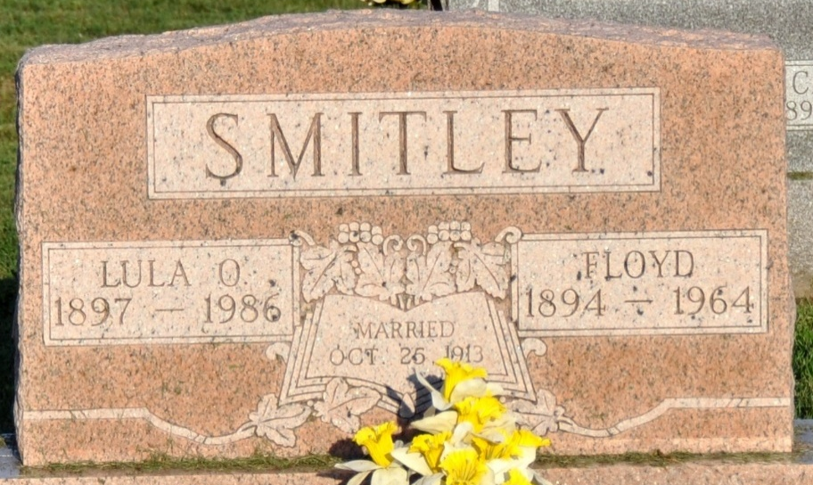
Photo by Deb Curry

Lula Opal Smitley, 89, route 2, Decatur, died at 6:24 p.m. Sunday at Ossian Health Care Center. A patient there since March 1 of 1983, she had been ill several months.
Born June 22, 1897 in Tipton County, Indiana, she was the daughter of Thomas W. and Dora Brown-Smitley (sic). She was married in 1913 to Floyd Smitley, who died December 16, 1964. A homemaker, she was a member of the Decatur Church of God.
Survivors include one daughter, Mrs. Lee (Violet May) McBride, Haines City, Florida; a sister, Mrs. Mabel Lundin, Lake Hamilton, Florida; a brother Guy Bess, Ossian; five grandchildren, 17 great-grandchildren, 9 great-great-grandchildren and three step-great-grandchildren.
Funeral services will be held at 1:30 p.m. Wednesday at Zwick-Boltz & Jahn Funeral Home, Rev. Kenneth Mishler in charge; burial will be in Decatur Cemetery. Friends may (sic) from 2-5 and 7-9 p.m. Tuesday at the funeral home.

Decatur Daily Democrat, Adams County, Indiana
August 25, 1986
**
LULA OPAL SMITLEY
Services for Lula Opal Smitley, 89, route 2, Decatur, will be held Wednesday at 1:30 p.m. at Zwick-Boltz & Jahn Funeral Home, where friends may call from 2-5 and 7-9 p.m. today. She was the daughter of Mr. and Mrs. Thomas Bess.

Decatur Daily Democrat, Adams County, Indiana
Aug 26, 1986

