Lucile H. (Trim) Smitley
February 10, 1904 – July 20, 1984

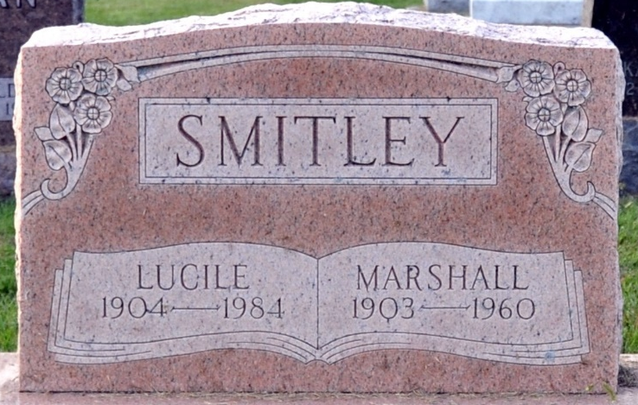
Photo by Deb Curry

Lucille H. Smitley, 80, of Glenridge Village, Glendale, Arizona, died at 9:15 p.m. Friday in a Glendale Hospital. The former Decatur resident was a homemaker, a member of the Presbyterian Church in Glendale and a member of the Rebekhah Lodge.
She was born February 10, 1904, in Decatur, the daughter of William H. and Mary Ellen Hill-Trim. She was married to Marshall Smitley on December 23, 1922; he preceded in death.
Surviving are two sons, Harry E. Smitley and George W. Smitley, both of Phoenix, Arizona; two sisters, Mrs. Leota Zezula of Huntingdon and Mrs. Marjorie Ladis of New Haven; two brothers, Virgil Trim and Bernard Trim, both of Fort Wayne; six grandchildren and 1 great-grandchild. Two brothers are deceased.
Funeral services will be held at 10 a.m. Thursday in Winteregg-Linn & Haggard Funeral Home, Rev. Thomas R. Steensma in charge; burial will be in Decatur Cemetery. Friends may call at the funeral home from 3-5 and 7-9 p.m. Wednesday.

Decatur Daily Democrat, Adams County, Indiana
Tuesday, July 24, 1984

