Louisa Jane (Clark) Smitley
October 17, 1876 – October 18, 1958

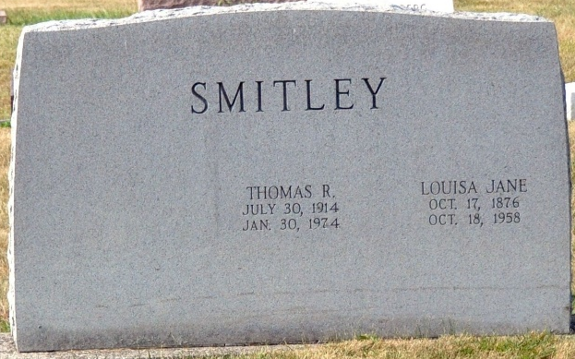
Photo by Deb Curry

Louisa Jane Smitley
in the Indiana, U.S., Death Certificates, 1899-2017

Name Louisa Jane Smitley
[Louisa Jane Clark]
Gender Female
Race White
Age 82
Marital Status Widowed
Birth Date 17 Oct 1876
Birth Place Darth County- Ohio
Death Date 18 Oct 1958
Death Place Decatur, Adams, Indiana, USA
Death Registration Date 1958
Father: Robert Clark
Mother: Crosby Saach
Informant: Russell Smitley; son
Burial: October 21, 1958; Decatur Cemetery; Decatur, Indiana

