Louis E. Smitley
November 6, 1923 – June 10, 1968

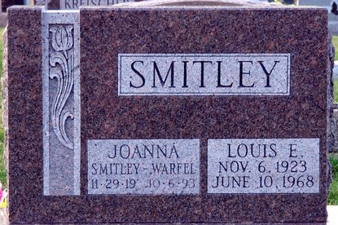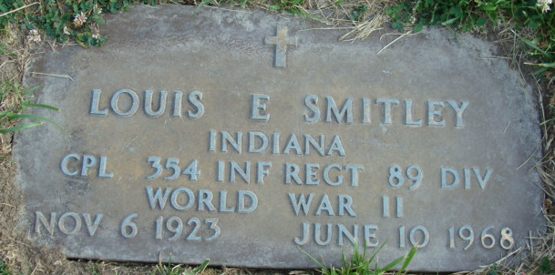
Photo by Deb Curry

Louis E Smitley
in the Indiana, U.S., Death Certificates, 1899-2017
Name Louis E Smitley
Gender Male
Race White
Marital Status Married
Age 44
Birth Date 6 Nov 1923
Birth Place Indiana
Death Date 10 Jun 1968
Death Place Fort Wayne, Allen, Indiana, USA
Death Registration Date 1968
Father Melvin Smitley
Mother Lulu M McKean
Spouse Joanna Daily
Informant VA Hospital records; Fort Wayne, Indiana
Burial June 13, 1968; Decatur Cemetery; Decatur, Indiana

